Name:  Teacher: | ____________________________________  ________________ |  | Date:_________
 | Year 9 Mathematics  SCORE:  /29  Mini test  Topic – Linear Equations  Full working out MUST be shown to get full marks for each question.
Total Time: | 30 minutes
Weighting: | 7 %
Equipment: | To be provided by the student: Pens and Pencils, scientific calculator, A4 page of notes.

- [5 marks] Vertical and horizontal distances
Consider the following graph
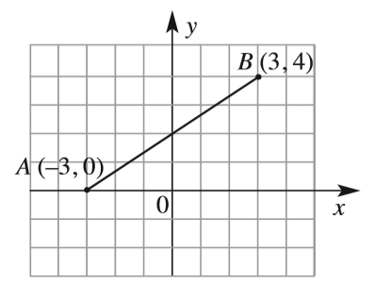 | - What is the vertical distance between A and B?  - What is the horizontal distance between A and B?  - What is the distance between A and B?  - What is the coordinate of the midpoint between A and B

- [6 marks]
A line connects the two points (-3,5) and (1, -3)

- Find the distance between the two points

- Find the mid-point

- What is the gradient of the line connecting the two points?

- [4 marks]
A triangle is formed using the points (-1, 3), (4, 8) and (3,-2) what is the perimeter of triangle?

- [6 marks]
Sketch the following graphs on the set of axes (Label your graphs)

- $y=x+2$ | - $y=-2x+3$ | - $2x+y=10$
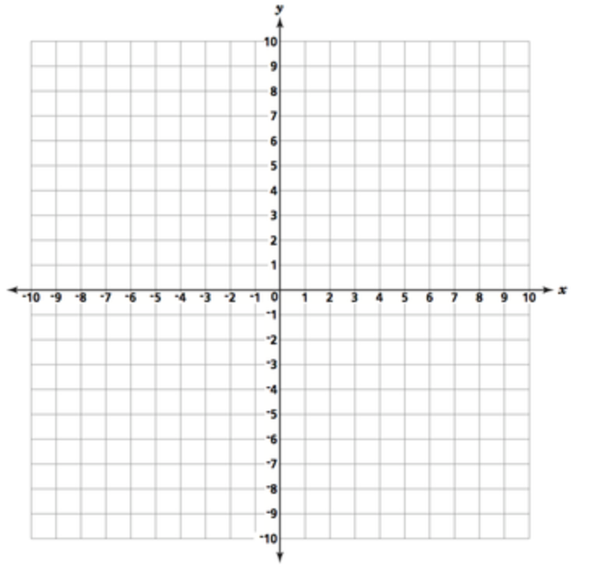

- [4 marks]
Determine the rule for the following in the for $y=mx+c$
x 1 2 3 4  y 5 7 9 11 | 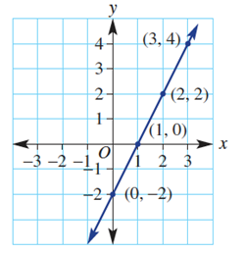

- [4 marks]
Match the equation to the graph
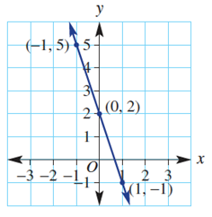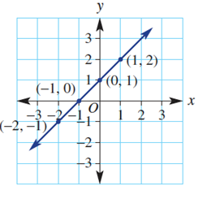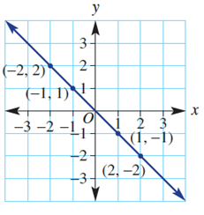 | - $x+y=0$  - $y-x=1$  - $y=-3x+2$

End of Test

